[Flow Charts]
[LCCS Project]

Computer Science

TEACHER: Pat Brennan
COURSE: LCCS
ACADEMIC LEVEL: Honors
ACADEMIC YEAR: 2024 - 25
TOPIC: Flow Charts

[The Institute of Education]
[LCCS]

Flow Chart Symbols

Marks the beginning of a program.
Start

Marks the end of a program.
Stop

Used to ‘Read’ in values.
Read Value A
‘Read In’ values means to enter values.

Denotes a process to be carried out.
(G1+G2+G3+G4) / 4

A process might be to add, subtract, multiply, divide etc.

Denotes a decision to be made.
Is grade < 50
If / Then / Else

Denotes an output program
Print
‘Fail’
e.g. Print the result of something
Note: Print here means ‘to show’ or ‘to display’.

Denotes the direction of a logic flow in the diagram

Sample 1  Create a flow chart that sums two number and prints out the result.  Sum of Two Numbers | Sample 2  Create a flow chart that reads in length and width, calculates area and prints out the result.  Area of Rectangle
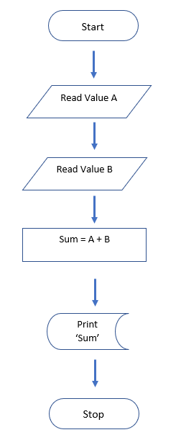 | 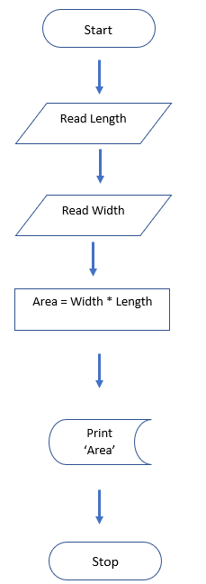

Exercise 1
Create a flow chart that classifies animals as either herbivore {only eats plants} or carnivore {eats meat.}

Exercise 2
Draw a flow chart where four grades are inputted and then averaged. If the grade is over 50, the word ‘Pass’ is printed and if it is less than 50, ‘fail’ is printed.

Exercise 3
Draw a flow chart that reads in two values (that means where two values are inputted) and displays the largest of the two values.

Exercise 4
Create a flowchart that shows the process of deciding how to get to school: If you leave home and the time is before 7:00 AM, take the subway; otherwise, take the bus. The flowchart should start with leaving home and end with reaching school.

Exercise 5
A, B and C are the grades of a student for Science, Maths or English.
Draw a flow chart that determines whether the student should be awarded a star or encouraged to do better. Hint! Average the grades

Exercise 6
Draw a flow chart that determines whether a number entered is even or odd?

Exercise 7
Draw a flow chart that converts length in feet to centimetres.
Formula: feet * 30.48

Exercise 8
Create a flowchart to represent the process of seeking admission to a school.

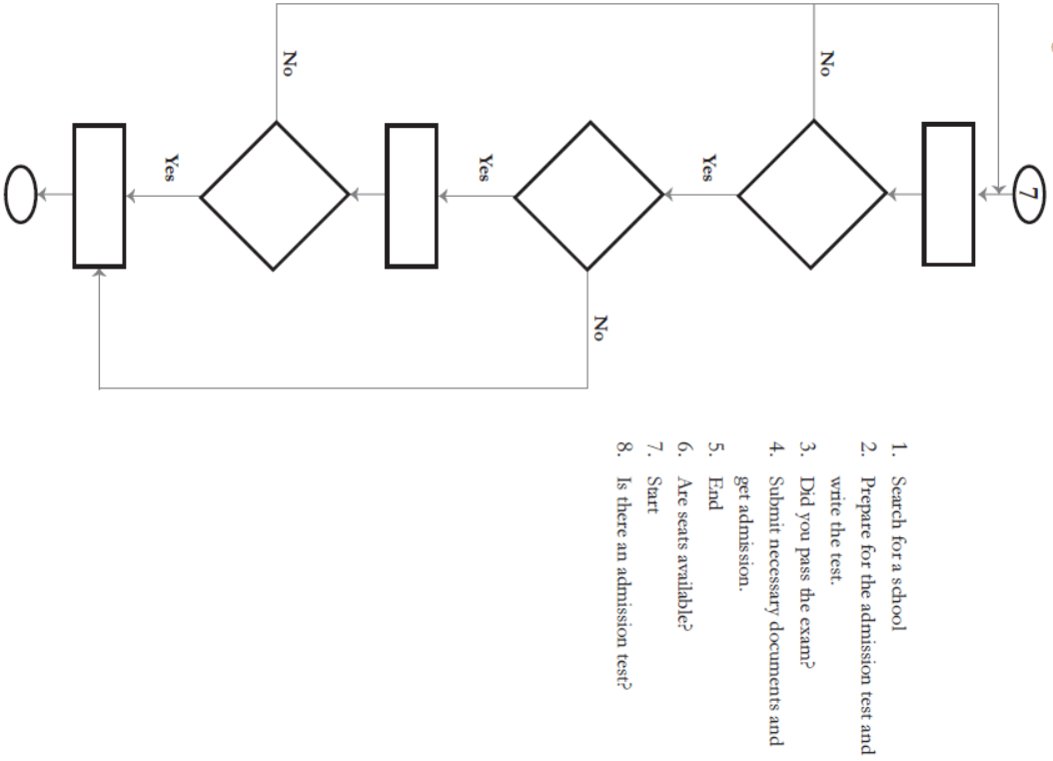

Solution
1. Search for School
2. Prepare for the admission test and write the test
3. Did you pass exam
4. Submit necessary documentation and get admission
5. End
6. Are there seats available
7. Start
8. Is there an admission test

Exercise 9
Create a flow chart that reads in Cost Price and Selling Price. It then calculate which of them is the largest. Depending on the answer, a profit or loss is created and printed out.
CS = Cost Price
SP = Selling Price

Exercise 10
Create a flow chart that asks users how many hours a week they work and how much they earn per hour. It then calculates how much money they earn a week and outputs ‘Can afford to live alone’ if earn 400 or more per week and ‘Cannot afford to live alone’ if earn less than 400.

